$$Machine learning$$

$$Step-1:Read the data$$

$$Step-2:EDA$$

$$Step-3:Model development$$

$Machine learning$

$Deep learning$

$NLP$

$GenAI$

$$Step-4:Model Evaluation$$

$$Step-5:Model tuning \left(Hyper parameter tuning\right)$$

$$Step-6:Model deployment$$

$$Machine learning$$

$Supervised learning:$

$$data has both input columns and output columns$$

$classification:Target column is in the form categorical data type$

$Logistic Regression$

$Decision tree$

$Naive bayes$

$KNN:K nearest neighbours$

$Support vector machine$

$Ensemble methods:$

$Bagging : Random forest$

$Boosting:Gradient boost , Ada boost, xgboost$

$Recommendation engine$

$Regression:Target column is un the form of Numerical data type$

$Linear regression$

$Lasso regression$

$Ridge regression$

$Elastic net regression$

$Unsupervised learning:Only data-No objective \left(No target column\right)$

$K-means$

$Heirarchical cluster$

$Density based cluster$

$$Linear regression$$

$$Whenever you see Linear term :power=1$$

$$AAA$$

$$Suppose you are nykaa manager ,$$

$$your objective is wants to increase the sales$$

$$so you decided in order to increase the sales need to do advertisement$$

$$You choose 3 media$$

$$SM NP TV$$

|  |  |  |  |
| --- | --- | --- | --- |
| $$SM$$ | $$NP$$ | $$TV$$ | $$Sales$$ |
| 200 | 300 | 400 | 1000 |
| 300 | 400 | 500 | 1400 |
| 150 | 250 | 600 | 2000 |
| 500 | 100 | 200 | 2500 |
| 1000 | 500 | 300 | ? |

$$what are the input columns: SM TV NP$$

$$what is the output column: Sales$$

$$sales is depends on sm,tv,np$$

$$sales=5*SM+1*TV+1*NP=====(1)$$

$$ps=10*G+1*O+1*S+1*R$$

$$sales=w_{Sm}*SM+w_{tv}*TV+w_{np}*NP$$

$$y=b_{0}+b_{1}*x_{1}+b_{2}*x_{2}+b_{3}*x_{3}+….+b_{n}*x_{n}$$

$$Linear regression equations are two types:$$

$simple linear regression equation$

$Means it has only one input column$

$y=b_{o}+b_{1}*x_{1}$

$sales=b_{o}+b_{1}*sm$

$Multiple linear regression$

$Multiple means more than one variable$

$y=b_{o}+b_{1}*x_{1}+b_{2}*x_{2}+b_{3}*x_{3}$

$sales=b_{o}+b_{1}*sm+b_{2}*np+b_{3}*tv$

$Genearally we will work with mutiple columns$

$$where:$$

$$b_{o}:bias or intercept$$

$$b_{1},b_{2},b_{3}…b_{n}: Coeffiecinets or slope$$

$$y=depenedent varaible or target column$$

$$x_{1},x_{2},x_{3},…x_{n} =independent variables or Input columns$$

$$Math analogy:$$

$$whenever you see the regression equation , we need to recall line equation$$

$$LR: y=b_{o}+b_{1}*x_{1}$$

$$ssc: y=mx+c$$

$$b_{1}=m=slope$$

$$c=b_{o}=intercept$$

$$ax+by+c=0$$

$$by=-ax-c$$

$$y=-\frac{a}{b}*x-\frac{c}{b}$$

$$what is meant by slope and intercept:$$

$$slope is denoted with m$$

$$m=tanθ$$

$$m={(y}_{2}-y_{1})/(x_{2}-x_{1})$$

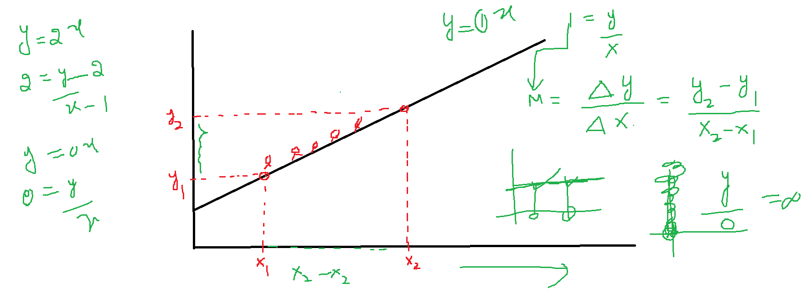

$$tanθ$$

$$tan0=0$$

$$tan45=1$$

$$tan90=inf$$

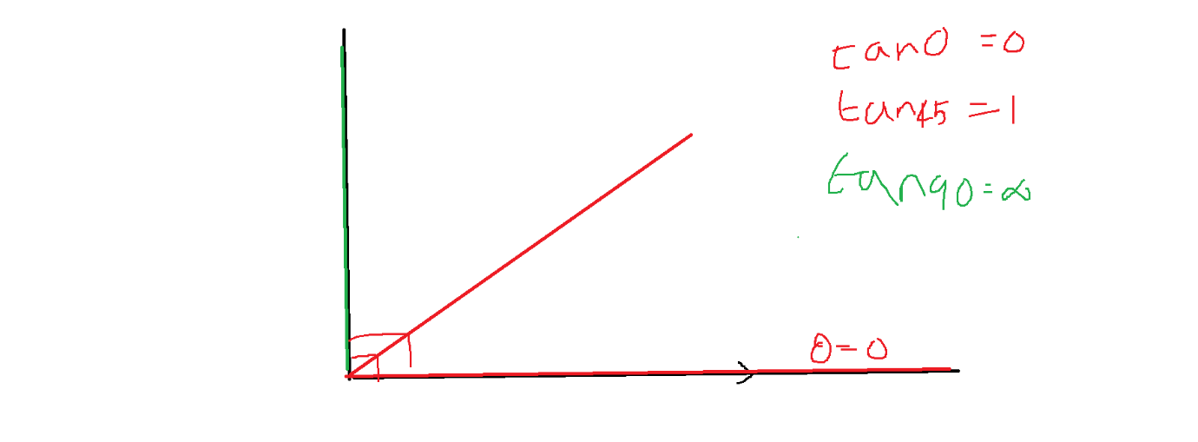

$$slope=The rate of change in y-direction w.r.t the rate of change in x-direction$$

$$Rate of change is called Gradinet$$

$$Δy=dy=y_{2}-y_{1}$$

$$Δx=Δx=x_{2}-x_{1}$$

$$m=\frac{Δy}{Δx}=\frac{dy}{dx}=\frac{{y_{2}-y}_{1}}{{x_{2}-x}_{1}}=derivative$$

$$m=0 means we are moving in x direction but no change in y-direction$$

$means there is no slope$

$m=tanθ$

$$θ=0 ;m=0$$

$$m=1 means we are moving in x direction by one unit the same one change in y-direction$$

$means there is slope=1$

$$θ=45 ;m=1$$

$$m=inf means we are not in x direction but try to move in y-direction$$

$means there is huge slope , the move is not possibile$

$$θ=90 ;m=inf$$

$$y=x y=2x y=3x$$

|  |  |  |  |
| --- | --- | --- | --- |
| $$x$$ | $$y=x$$ | $$y=2x$$ | $$y=3x$$ |
| $$1$$ | $$1$$ | $$2$$ | $$3$$ |
| $$2$$ | $$2$$ | $$4$$ | $$6$$ |
| $$3$$ | $$3$$ | $$6$$ | $$9$$ |
| $$4$$ | $$4$$ | $$8$$ | $$12$$ |
| $$5$$ | $$5$$ | $$10$$ | $$15$$ |
| $$6$$ | $$6$$ | $$12$$ | $$18$$ |

$$y=x ====== > m=1$$

$$y=2x====== >m=2$$

$$y=3x===== >m=3$$

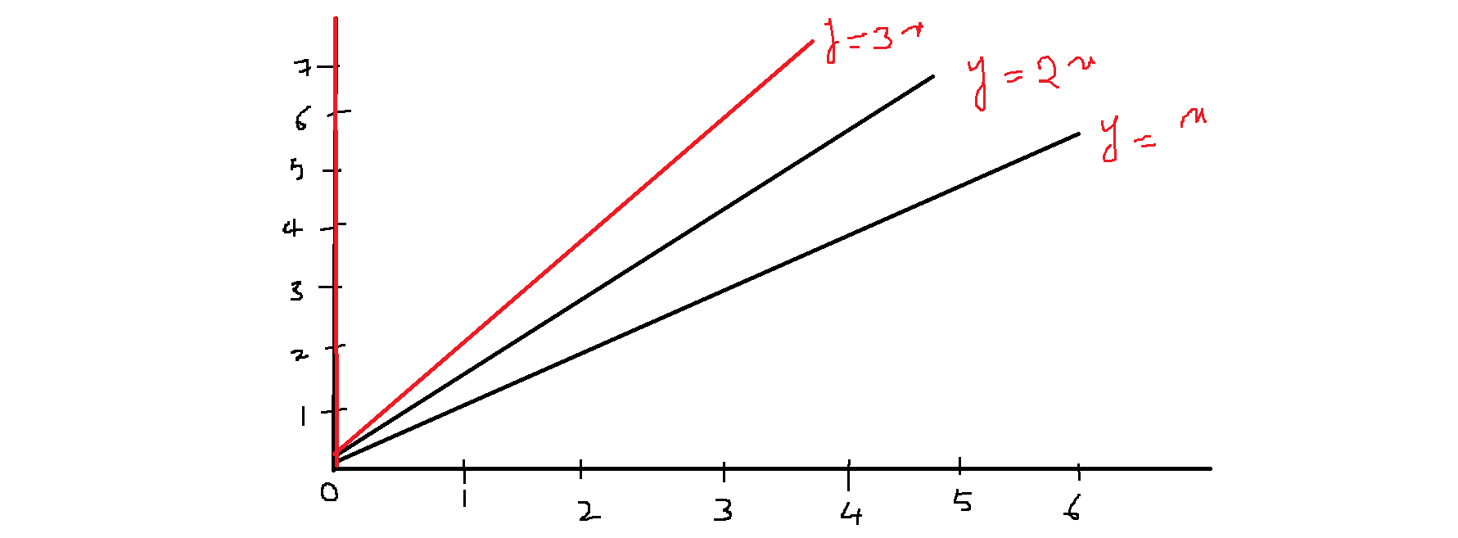

$$Observation:$$

$slope changes the line equation will change$

$slope is the responsible to line rotation$

$In order to get the good line we required correct slope value$

$y and x will give only linear line$

$but m will postition of the line$

$in our linear regression{{}_{}^{'}m}^{'} means b_{1} b_{2} b_{3}$

$so our goal Linear regression is find the suitable coefficients :b_{1}, b_{2} b_{3}$

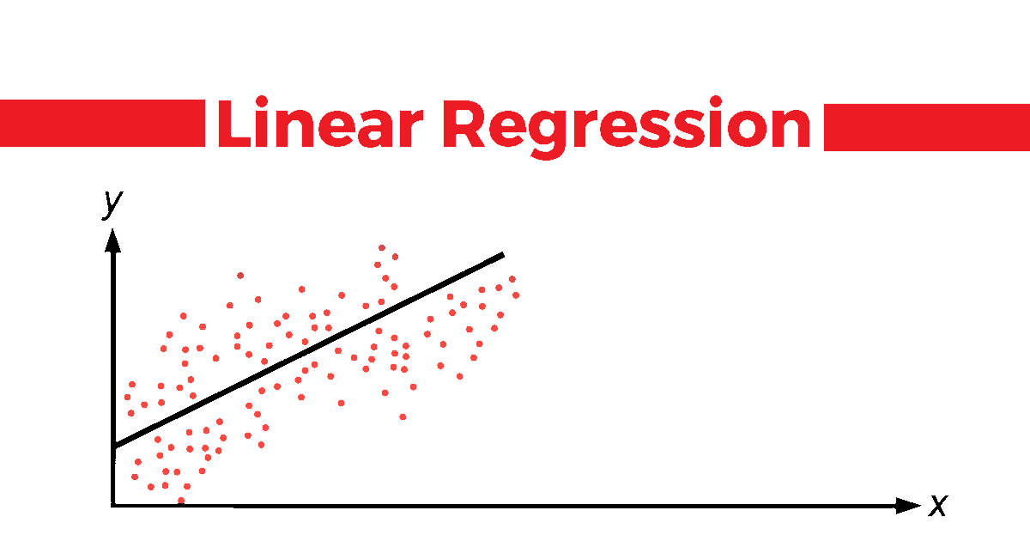

$$Intercept:$$

$$y=x y=x+1 y=x+2$$

|  |  |  |  |
| --- | --- | --- | --- |
| $$x$$ | $$y=x$$ | $$y=x+1$$ | $$y=x+2$$ |
| 0 | 0 | 1 | 2 |
| $$1$$ | $$1$$ | $$2$$ | $$3$$ |
| $$2$$ | $$2$$ | $$3$$ | $$4$$ |
| $$3$$ | $$3$$ | $$4$$ | $$5$$ |
| $$4$$ | $$4$$ | $$5$$ | $$6$$ |
| $$5$$ | $$5$$ | $$6$$ | $$7$$ |
| $$6$$ | $$6$$ | $$7$$ | $$8$$ |

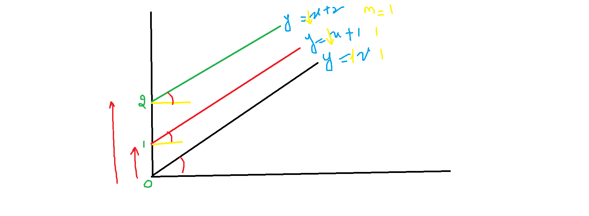

$Observations$

$$intercept is indicates change line of starting position$$

$$we take 3 line equation y=x , y=x+1 and y=x+2$$

$$here the intercepts are 0 , 1 and 2$$

$$the line postition also start at 0 ,1 and 2$$

$slope is responsible for rotation of the line$

$Intercept is responsible for lift the line$

$linear regression line given by ML model$

$It should pass through the data points$

$In order to draw the line we need two things$

$what is the starting postion: Intercept$

$which direction the line move: slope$

$$SSC: y=c+m_{1}*x_{1}+m_{2}*x_{2}$$

$c=intercept$

$m_{1} and m_{2} slopes$

$$Machine learning: y=b_{o}+b_{1}*x_{1}+b_{2}*x_{2}$$

$b_{o}=bias$

$b_{1},b_{2}=coeffiecients$

$$deep learning: y=w_{o}+w_{1}*x_{1}+w_{2}*x_{2}$$

$w_{o}=bias$

$w_{1},w_{2}=weights$